|  |
| --- |
| Predictive Health Notification  Alinity c Cuvette Wash |
| ALINITY c Clinical Chemistry Analyzer  Nate Parks  November 18, 2018 |

**PHN - Alinity c Cuvette Wash Spec Sheet for Apollo**

**References**

D000062792/A Cuvette Status Alert Algorithm Design Document ALINITY c Clinical Chemistry Analyzer

**Summary**

To implement a Predictive Health Notification (PHN) for Alinity-c Analyzers that will detect cuvette wash tower malfunction.

|  |  |
| --- | --- |
| PHN Descriptor | Alinity CC Cuvette Wash |
| PHN Experience Code / Name | B97K PHN_Alinity_CC; PHN_Cuvette: Wash |
| PHN KM Article Number/ Name | K41225806 PHN_Alinity_CC: Cuvette Wash |
| Service Level | 2- Advanced Service |
| Always On Package | Always On 01DP4- 01, 02, 03, 09, 70, 79, 80, 83, 84, 89 |
| IDA Table(s) | IDAQOWNER.ICQ_CCSAMPLEDISPCI SDP  IDAQOWNER.ICQ_CCDISPENSEPM DPM  IDAQOWNER.ICQ_RESULTS R |
| IDA Table Fields | SDP.SYSTEMSN,  SDP.LOGDATE_LOCAL,  SDP.DISPENSEBEGINAVERAGE,  SDP.SAMPLEKEY,  SDP.TESTNUMBER,  SDP.REPLICATESTART,  SDP.REPLICATENUMBER,  DPM.MODULESN,  DPM.SYSTEMSN,  DPM.LOGDATE_LOCAL,  DPM.SAMPLEKEY,  DPM.TOSHIBATESTNUMBER,  DPM.STARTINGREPLICATENUMBER,  DPM.REPLICATENUMBER,  DPM.TESTID,  R.SYSTEMSN,  R.TESTID,  R.CUVETTENUMBER,  SDP.DISPENSEBEGINAVERAGE |
| Analysis Frequency | Daily |
| Data Required | Previous 7 days |
| Data Aggregation | None |
| Run Time Estimate | N/A |
| Flag Criteria | **From Architect PHN00064**: DisBeginAveV > 20,000 for > 20% of all sampling events for > 20%* of all cuvettes (A- and B-lines of c16000 instruments are treated separately).  **For Alinity**: DISPENSEBEGINAVERAGE > 20,000 for > 20% of all sampling events for > 37* cuvettes.  *Note that for Alinity, “for > 20% of all cuvettes” translates to “for > 37 cuvettes”. Given that Alinity c has 187 cuvettes, 20% of that is approximately 37. Also, Alinity does not have A- and B-lines like Architect. |
| Probable Failure Modes | Clogged or dirty dryer tip Clogged or bent wash nozzles Clogged, pinched, leaking or disconnected tubing Wash tower alignment Sample probe calibration |
| Suppression Experience Codes | BJT (Z,3,6,D,4,5,7,1,H,9,U,S)  BJ1Z, BJ4(Z,6,H,9,U)  A31 (Z,7,1)  Z60O: 4703 Cuvette integrity check failed on cuvette (0).  Z61H: 5112 Cuvette washer lower limit not found.  Z73E: 5651 Cuvette washer movement restricted at position (0) step number (1).  Z3UO: 3423 Cuvette washer water volume (0). Cuvette (1) volume (2). |
| Applicable Work Done Codes (WDC) | CJ** Fluid Movement Cuvette Wash Pump  CT** Fluid Movement Cuvette Wash Pump Valve  BP** Fluid Aspiration, Dispense and Detection Cuvette Washer  F7** Optics/Detector Cuvette |

**Data Processing Steps**

|  |  |
| --- | --- |
| Data Processing Steps | |
| 1 | Query all data from the previous 7 days for each instrument (IDA Tables: IDAQOWNER.ICQ_CCSAMPLEDISPCI, IDAQOWNER.ICQ_CCDISPENSEPM, IDAQOWNER.ICQ_RESULTS) |
| 2 | Exclude cuvettes where the number of sampling events is less than 20. |
| 3 | Exclude rows where the cuvette number is null. |
| 4 | Identify cuvettes with sampling events having DISPENSEBEGINAVERAGE > 20,000. |
| 5 | For cuvettes with sampling events having DISPENSEBEGINAVERAGE > 20,000, calculate the percent of sampling events for individual cuvettes having DISPENSEBEGINAVERAGE > 20,0000. |
| 6 | Calculate the number of cuvettes with > 20% of all sampling events having DISPENSEBEGINAVERAGE > 20,000. |
| 7 | Flag any instrument where DISPENSEBEGINAVERAGE > 20,000 for > 20% of all sampling events for > 37 cuvettes. |

**APPENDIX 1:** B97K PHN_Alinity_CC; PHN_Cuvette: Wash

**Algorithm Code**

SELECT

final.MODULESN

FROM

(SELECT

middle1.*,

(middle1.NUM_SAMPEVENTS_GT20000_PERCUV / middle1.NUM_SAMPEVENTS_PERCUV) AS PERC_SAMPEVENTS_GT20000_PERCUV,

CASE WHEN (middle1.NUM_SAMPEVENTS_GT20000_PERCUV / middle1.NUM_SAMPEVENTS_PERCUV) > 0.2

THEN 1

ELSE 0

END AS GT20000_GT20PERC_SAMPEVENTS

FROM

(SELECT

inner1.MODULESN,

inner1.CUVETTENUMBER,

COUNT(inner1.CUVETTENUMBER) AS NUM_SAMPEVENTS_PERCUV,

SUM(inner1.CHECK_GT20000) AS NUM_SAMPEVENTS_GT20000_PERCUV

FROM

(SELECT

SDP.SYSTEMSN,

SDP.LOGDATE_LOCAL,

SDP.DISPENSEBEGINAVERAGE,

SDP.SAMPLEKEY,

SDP.TESTNUMBER,

SDP.REPLICATESTART,

SDP.REPLICATENUMBER,

DPM.MODULESN,

DPM.SYSTEMSN,

DPM.LOGDATE_LOCAL,

DPM.SAMPLEKEY,

DPM.TOSHIBATESTNUMBER,

DPM.STARTINGREPLICATENUMBER,

DPM.REPLICATENUMBER,

R.SYSTEMSN,

R.TESTID AS RESULTS_TESTID,

R.CUVETTENUMBER,

CASE WHEN SDP.DISPENSEBEGINAVERAGE > 20000

THEN 1

ELSE 0

END AS CHECK_GT20000

FROM

IDAQOWNER.ICQ_CCSAMPLEDISPCI SDP

LEFT JOIN IDAQOWNER.ICQ_CCDISPENSEPM DPM

ON SDP.SYSTEMSN = DPM.SYSTEMSN

AND DPM.LOGDATE_LOCAL

BETWEEN SDP.LOGDATE_LOCAL - INTERVAL '0.1' SECOND AND SDP.LOGDATE_LOCAL + INTERVAL '0.1' SECOND

AND SDP.SAMPLEKEY = DPM.SAMPLEKEY

AND SDP.TESTNUMBER = DPM.TOSHIBATESTNUMBER

AND SDP.REPLICATESTART = DPM.STARTINGREPLICATENUMBER

AND SDP.REPLICATENUMBER = DPM.REPLICATENUMBER

LEFT JOIN IDAQOWNER.ICQ_RESULTS R

ON DPM.SYSTEMSN = R.SYSTEMSN

AND DPM.TESTID = R.TESTID

WHERE

SDP.LOGDATE_LOCAL >= TRUNC(SYSDATE) - 7

AND SDP.LOGDATE_LOCAL < TRUNC(SYSDATE)

AND R.CUVETTENUMBER IS NOT NULL) inner1

GROUP BY

inner1.MODULESN,

inner1.CUVETTENUMBER

ORDER BY

inner1.MODULESN,

inner1.CUVETTENUMBER) middle1) final

WHERE

final.GT20000_GT20PERC_SAMPEVENTS = 1

GROUP BY

final.MODULESN

HAVING

COUNT(final.MODULESN) > 37

ORDER BY

final.MODULESN

**Apollo Algorithm Details**

(* is Mandatory)

|  |  |
| --- | --- |
| **Apollo Details** |  |
| Algorithm ID * | Alinity CC Cuvette Wash |
| Algorithm Name * | Alinity CC Cuvette Wash |
| Algorithm Description * | To detect cuvette wash problems. |
| Product Family * | Alinity CC |
| Algorithm Group * | Alinity Cuvette |
| Functional Area | N/A |
| Algorithm Category 1 | N/A |
| Algorithm Category 2 | N/A |
| Algorithm Category 3 | N/A |
| Remaining Useful Life Value | 7 |
| Remaining Useful Life Unit | Day |
| Keep Results Num Days | 14 |
| **Routine Details** |  |
| Routine Source | Define New Routine |
| Routine Type | Oracle Procedure |
| Run Mode | Batch |
| Routine Invoke Command | PHM_ICQ_Cuvette_Wash_PROC |
| Status | Enable |
| **ODS Routine Details** |  |
| ODS Routine Name | PHM_ODS_ICQ_CC_RESULTS_PROC |
| **Predictive Health Notification Details** |  |
| PHN Code | PHN_Alinity_CC_B97K |
| Issue Description (Use Algorithm Name) |  |
| Experience Code | B97K |
| **Knowledge Management DB Articles** |  |
| KM Article ID | K41225806 |
| KM Article | PHN_Alinity_CC: Cuvette Wash |
| **Parameters** |  |
| Parameter Group Name | ICQ_Cuvette_Wash |
| **Parameter Name** | **Parameter Values** |
| IHN_LEVEL3_DESC | Alinity CC Cuvette Wash |
| CUVETTEWASH_DISBEGAVG_MIN | 20000 |
| CUVETTEWASH_PERCSAMPEVENTS_MIN | 0.2 |
| CUVETTEWASH_NUMCUVETTES_MIN | 37 |
| THRESHOLD_COUNT | 1 |
| THRESHOLD_DESCRIPTION | Alinity CC Cuvette Wash |
| **Chart Details** |  |
| Chart Title | Alinity CC Cuvette Wash |
| Chart Type | Line |
| Chart Threshold Parameter | ICQ_Cuvette_Wash-THRESHOLD_COUNT |
| Group ID | Group 7 |
| Chart X Axis Name | Date |
| Chart Y Axis Name | Threshold Count |

**APPENDIX 2:** Algorithm Understanding Check – Algorithm Developer to Predictive Health Monitoring (PHM) Specialist Transition

This step is not necessary. Originally designed for Architect, this algorithm was directly converted/re-coded to work on Alinity. As such, there was no “hand-off” of the algorithm from Algorithm Developer to PHM Specialist, and no Understanding Check was necessary. Proper algorithm functionality was checked by the PHM Specialist.

**APPENDIX 3:** Algorithm Verification in Apollo

**Data Set Description**

The data set for this transition was retrieved from the IDAQOWNER.ICQ_CCSAMPLEDISPCI, IDAQOWNER.ICQ_CCDISPENSEPM and IDAQOWNER.ICQ_RESULTS tables within the DABBTO database. Data was collected for all available instruments on September 16, 2018 and September 18, 2018. Note that in order to generate algorithm violations, for verification purposes only, the DISPENSEBEGINAVERAGE threshold was lowered from 20,000 to 10,000. The threshold will be returned to 20,000 once verification is complete.

**PHM Specialist Analysis Output**

The following instruments (MODULESN) were identified as violating the algorithm by the PHM Specialist:

From 09/16/2018:

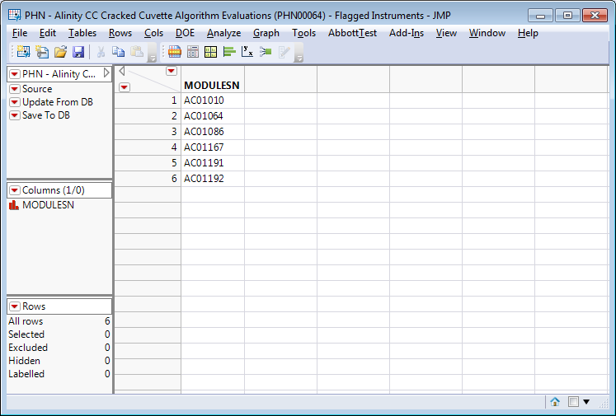

From 09/18/2018:

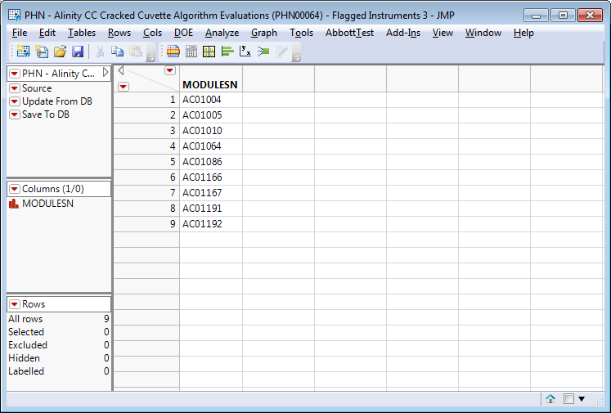

**Apollo Developer Analysis Output**

The following instruments (SN) were identified as violating the algorithm by the Apollo Developer (note that where the Apollo Developer and PHM Specialist don’t match is because the instruments and/or data do not exist in the Apollo environment, and as such, there is no data to run the algorithm against):

From 09/16/2018:

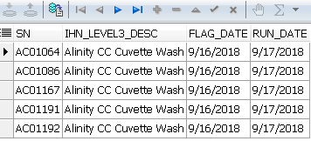

From 09/18/2018:

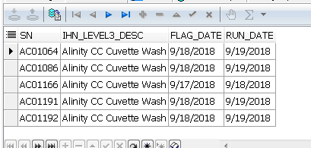

**Algorithm Transition Summary**

Based on the outputs from both the Apollo Developer and PHM Specialist, the Apollo Developer’s understanding of the delivered algorithm is confirmed. Both the Apollo Developer and PHM Specialist analyzed the same data set and got the same results (with the exception of the instruments not in Apollo as mentioned previously). In particular, the MODULESN/SN fields matched for each day. This means that both the Apollo Developer and PHM Specialist flagged the same algorithm violations within the given data set.